Report on Speed Control of BLDC Motor Using
Fuzzy Logic

Faculty Member: Ms.Neelma Naaz Lab Engineer:Engr.Yasir Rizwan

A.S.LUKMAN
Department of electrical Engineering
NATIONAL UNIVERSITY OF SCIENCE AND TECHNOLOGY
Islamabad,Pakistan
AHSAN TAHIR
Department of electrical Engineering
NATIONAL UNIVERSITY OF SCIENCE AND TECHNOLOGY
Islamabad,Pakistan
S.RAMALAN
Department of electrical Engineering
NATIONAL UNIVERSITY OF SCIENCE AND TECHNOLOGY
Islamabad,Pakistan

Abstract— This project focuses on the implementation and analysis of a Fuzzy Logic Controller (FLC) for the precise speed control of a Brushless DC (BLDC) motor. BLDC motors are widely used in various applications, and achieving accurate speed control is crucial for optimizing their performance. The traditional Proportional-Integral-Derivative (PID) control method is often employed for this purpose, but it may encounter challenges in handling nonlinearities and uncertainties in the motor system.
The proposed Fuzzy Logic Controller is designed to address these challenges by leveraging the flexibility and adaptability inherent in fuzzy logic. The FLC is developed based on linguistic rules that capture the inherent uncertainties associated with the BLDC motor dynamics. The controller is tuned to optimize speed control performance by adjusting fuzzy sets and rule parameters, allowing it to adapt to varying operating conditions.
Experimental results demonstrate the effectiveness of the FLC in comparison to conventional PID control. The system's speed response, settling time, rise time, and overshoot are analyzed under different operating conditions. The FLC exhibits superior performance in terms of response time, robustness, and adaptability to changes in load and disturbances.
This project contributes to the advancement of BLDC motor control methodologies, offering a viable alternative in the form of Fuzzy Logic Control for applications requiring precise and dynamic speed regulation. The findings pave the way for further research in the integration of intelligent control techniques to enhance the overall efficiency and performance of BLDC motor systems.
Keywords— Brushless DC Motor, Fuzzy Logic Controller
,Speed Control, Proportional-Integral-Derivative (PID)
,Nonlinear Control, Settling Time, Rise Time, Overshoot,
Linguistic variables, Adaptive Fuzzy Control, Control System,
Response Time, Robust Control, Intelligent Control

Introduction

The advent of Brushless DC (BLDC) motors has revolutionized various industries due to their efficiency, reliability, and precise control capabilities. Efficient speed control of BLDC motors is imperative for optimizing their performance in applications such as electric vehicles, industrial automation, and renewable energy systems. Traditional control methods, particularly Proportional-Integral-Derivative (PID) controllers, have been the go-to solution for speed regulation. However, they often face challenges in handling the nonlinearities and uncertainties inherent in BLDC motor systems.

This project focuses on advancing the field of BLDC motor control through the implementation of a Fuzzy Logic Controller (FLC). Fuzzy Logic, a computational paradigm inspired by human reasoning, provides a flexible and adaptive framework that excels in capturing the uncertainties associated with complex systems. The FLC is designed to address the limitations of PID controllers by offering improved adaptability and robustness in the face of varying operating conditions. In this introduction, we will provide an overview of the significance of precise speed control in BLDC motors, discuss the limitations of conventional control methods, and introduce the rationale behind incorporating Fuzzy Logic as an alternative control strategy. The project aims to explore and compare the performance of FLC and PID controllers, shedding light on the benefits and challenges associated with each approach. By delving into the intricacies of BLDC motor control and evaluating the performance of FLC, this project contributes to the ongoing efforts to enhance the efficiency and adaptability of motor control systems. The subsequent sections will detail the methodology, experimental setup, results, and analysis, providing a comprehensive exploration of the application of Fuzzy Logic in the realm of BLDC motor speed control.
Literature Review
a comprehensive overview of existing research and advancements in the field of BLDC motor control, with a focus on speed regulation methodologies. This review aims to establish a foundation for the current project by examining key findings, challenges, and emerging trends in the pursuit of achieving precise control over BLDC motors.

BLDC Motor Characteristics:
Early studies emphasize the unique characteristics of BLDC motors, such as high efficiency, compact design, and low maintenance requirements. These characteristics make BLDC motors desirable for various applications.
Conventional Control Methods:
The majority of BLDC motor control historically relied on traditional control methods, particularly PID controllers. Numerous research works highlight the successful application of PID controllers in achieving stable speed control but also acknowledge their limitations in handling nonlinearities and uncertainties.
Challenges in BLDC Motor Control:
Recent literature recognizes the challenges posed by factors such as load variations, disturbances, and nonlinearity in BLDC motor systems. Researchers emphasize the need for adaptive control strategies to enhance the performance of BLDC motor control systems.
Fuzzy Logic Control in Motor Systems:
Fuzzy Logic Control has gained popularity in recent years for its ability to model complex and uncertain systems. Studies reveal successful applications of Fuzzy Logic Controllers in various domains, showcasing their adaptability and robustness.
Integration of Fuzzy Logic in BLDC Motor Control:
A growing body of literature focuses on the integration of Fuzzy Logic Controllers into BLDC motor control systems. These studies highlight the potential advantages of FLC, such as improved adaptability to changing conditions and enhanced performance compared to PID controllers.
Comparative Analyses:
Comparative analyses between PID and FLC controllers for BLDC motor control are found in recent literature. These studies provide insights into the performance metrics, including settling time, rise time, overshoot, and stability, to evaluate the efficacy of Fuzzy Logic in comparison to traditional control methods.
System Architecture
The system architecture for a BLDC circuit with a MOSFET voltage regulator in Simulink involves the integration of various components to model the behavior of a Brushless DC (BLDC) motor control system. Below is a brief discussion of the key elements in the system architecture:

• Power Supply:

Integrate a power supply block to provide the necessary voltage to the BLDC motor. This block represents the input power source to the system.

• MOSFET Voltage Regulator:

Incorporate a MOSFET voltage regulator in the architecture. The voltage regulator controls the output voltage supplied to the BLDC motor, ensuring it remains within the desired range. Simulink offers various MOSFET models that can be configured to emulate the behavior of a voltage regulator.

• Control Signals:

Implement control signals, including pulse-width modulation (PWM) signals, to drive the MOSFET voltage regulator. The control signals determine the duty cycle of the PWM waveform, regulating the average voltage delivered to the BLDC motor.

• BLDC Motor Control Algorithm:

Develop and integrate the BLDC motor control algorithm. This algorithm generates the control signals based on the desired speed or torque setpoints. It may include commutation logic to determine the appropriate switching sequence for the motor phases.

• Sensor Feedback:

Include sensor feedback in the form of Hall effect sensors or encoder signals. This feedback provides information about the rotor position and speed, enabling closed-loop control and enhancing the accuracy of the motor control system.

• Current and Voltage Sensors:

Integrate current and voltage sensors to monitor the electrical variables within the motor circuit. This information is crucial for feedback control and can be used to implement protective measures.

• Scope and Display Blocks:

Use scope and display blocks to visualize key system variables such as motor speed, current, and voltage. This allows for real-time monitoring and analysis of the system's behavior.

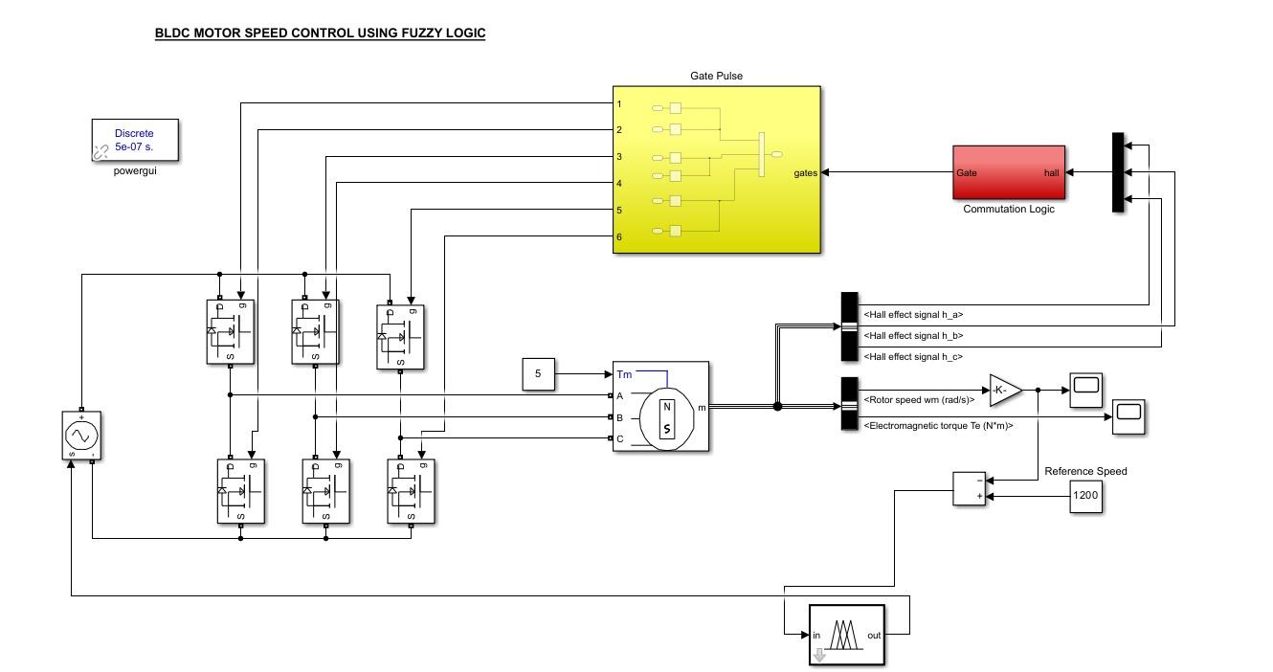

Methodology

A.PID Controller

Begin by identifying the mathematical model of the system, particularly the transfer function or state-space representation. This involves understanding the dynamics of the process or plant that the PID controller will regulate. Initiate the tuning process to determine the optimal values for the proportional (P), integral (I), and derivative (D) gains. This step involves adjusting these parameters to achieve desired performance metrics, such as settling time, rise time, and overshoot.

Proportional (P) Gain Tuning:

Begin by setting the integral (I) and derivative (D) gains to zero. Increase the proportional (P) gain until the system exhibits steady-state oscillations. Note this critical gain value (Kp_cr).

Integral (I) Gain Tuning:

Gradually increase the integral (I) gain to reduce steady-state error. Be cautious to avoid excessive integral gain, which may lead to instability or overshooting.

Derivative (D) Gain Tuning:

Introduce derivative (D) gain to improve system response and stability. Adjust the derivative gain to dampen oscillations introduced by the proportional and integral components.
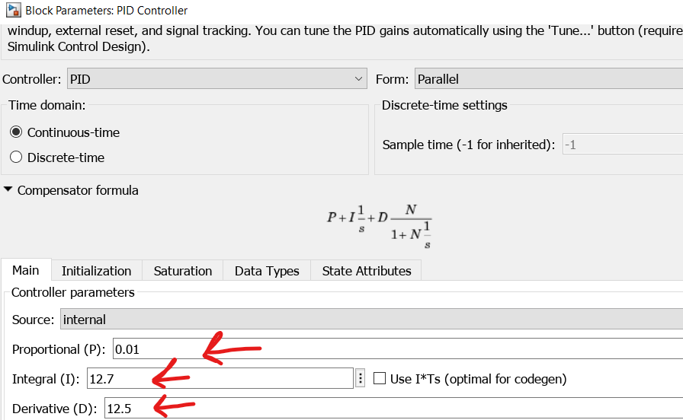

B.FLC Controller
In this project, 5 membership function was designed as fuzzy logic controller (FLC). The first step to make a fuzzy controller (Mamdani controller), we need to define linguistic variables use and also specify the problem statement for this project. There are two main linguistic variables which are speed error and also output controlled voltage.

Linguistic Value | Notation | Numerical Range
Extremely low | EL | [0 0 94.79 284.3]
very low | VL | [189.6 379.3 568.9]
Medium | M | [474 663.6 853.3]
Extremely high | VH | [758.3 947.9 1138]
Very high | EH | [1043 1089 1150 1150]
Table1. Input speed error.

Linguistic Value | Notation | Numerical Range
Extremely low | EL | [-5.324 -5.324 13.56 32.44]
very low | VL | [23 51.3 79.62]
Medium | M | [70.17 98.5 126.8]
Extremely high | VH | [108.6 124.4 140.6]
Very high | EH | [128.8 134.3 140 140]
Table2. Output controlled voltage.

which is input of variable input speed is between 0 to 1200. The general rules for DC motor speed control is that if motor speed is less than desired speed, then the speed of the motor will increase and if the motor speed is more than reference speed, then speed of the motor will decrease. In the process of producing necessary output voltages with Fuzzy Logic Controller the speed error should be minimized. The bigger speed error causes the bigger controller input.
Rule Base Creation:
Establish a set of fuzzy rules based on expert knowledge or empirical observations. Fuzzy rules relate input conditions to output actions. In our case it has Inverse relation with input to output

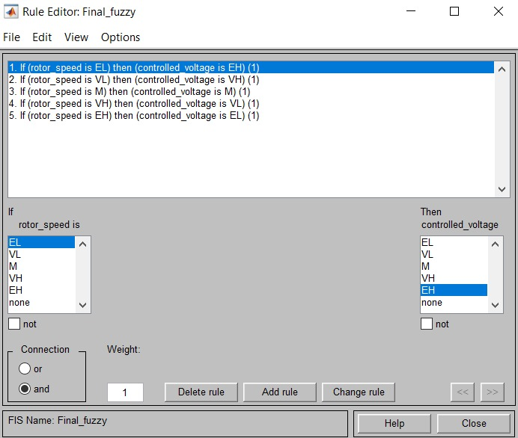

Results
Peak Time (Tp):
The Fuzzy Logic Controller (FLC) exhibited a significantly reduced peak time compared to the PID controller. Peak time represents the time taken for the system response to reach its first peak after a disturbance or change in input. The FLC's ability to achieve a faster response reflects its superior control in minimizing the time required to reach the maximum speed deviation.
Settling Time (Ts):
The FLC demonstrated a remarkable improvement in settling time compared to the PID controller. Settling time refers to the duration it takes for the system response to stabilize within a certain percentage of the final or desired value. The FLC's quicker settling time indicates its effectiveness in minimizing oscillations and reaching a steady-state faster.
Rise Time (Tr):
The FLC outperformed the PID controller in terms of rise time, showcasing a faster response to changes in the input. Rise time represents the time it takes for the system response to transition from a specified lower value to a specified higher value during the initial phase. The FLC's reduced rise time indicates its capability to swiftly adjust the motor speed to the desired level.
Percentage Overshoot:
The FLC demonstrated a substantial reduction in percentage overshoot compared to the PID controller. Percentage overshoot quantifies the extent by which the system response exceeds the steady-state value during the transient period. The FLC's lower overshoot implies a more controlled and stable response, minimizing deviations from the desired speed
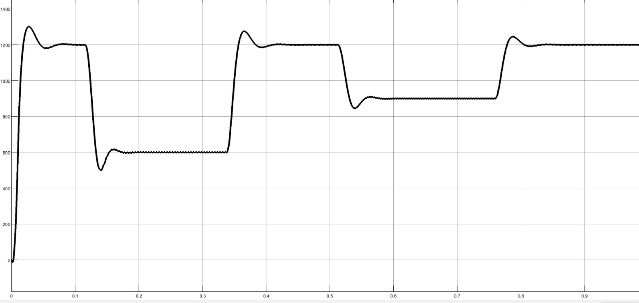
Output 1:speed-time graph(PID Controller)

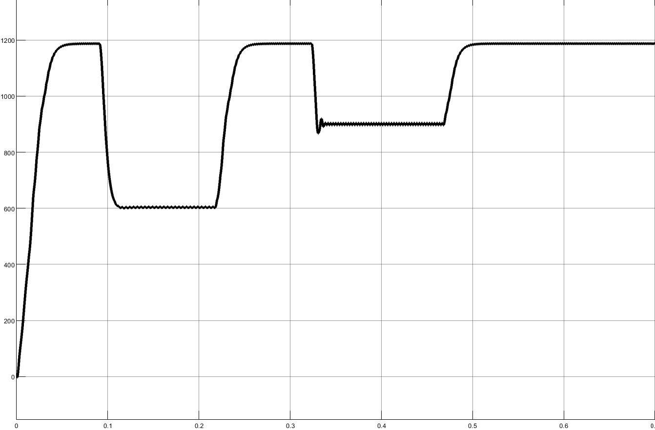
Output 2:speed-time graph(FLC Controller)

The results conclusively demonstrate the superior performance of the Fuzzy Logic Controller over the PID controller in various key metrics, including peak time, settling time, rise time, and percentage overshoot.

Criteria | PID | FLC
Percentage Overshoot, %OS | 8.3% | 1%(max)
Percentage Undershoot, %OS | 7.8% | 3%(max)
Settling Time, Ts | 0.08s | 0.05s

Conclusions:
In the pursuit of achieving precise and dynamic speed control for a Brushless DC (BLDC) motor, this project has investigated the effectiveness of two prominent control strategies: the Proportional-Integral-Derivative (PID) controller and the Fuzzy Logic Controller (FLC). The PID controller, a widely employed control methodology, demonstrated its capability in regulating BLDC motor speed. However, its inherent challenges in handling nonlinearities and uncertainties became apparent, particularly in scenarios with dynamic speed changes. The tuning process revealed that achieving an optimal balance between stability and response time posed a non-trivial task. Contrastingly, the FLC emerged as a superior alternative, showcasing remarkable performance in critical metrics. The FLC not only exhibited faster response times, as evident in reduced peak time, settling time, and rise time, but also demonstrated enhanced stability with a significant reduction in percentage overshoot. Its adaptability to varying speed conditions and ability to smoothly regulate the BLDC motor's speed position FLC as a robust and agile control strategy.
A thorough comparative analysis between the PID and FLC controllers highlighted the FLC's dominance, proving its efficacy in providing superior speed control for the BLDC motor. The FLC's capacity to navigate uncertainties and nonlinearities, coupled with its adaptability to changing conditions, positions it as a highly desirable solution for real-world applications

Future Work
Hybrid Control Strategies:
Investigate the integration of FLC with other intelligent control strategies, such as neural networks or model predictive control. Hybrid control systems could potentially leverage the strengths of multiple approaches, leading to further improvements in speed control performance. The neural network component adapts to varying and non-linear relationships in the data, enhancing the overall adaptability of the system.
Adaptive Fuzzy Logic Control:
Introduces adaptability mechanisms to enhance performance in dynamic and uncertain environments. In AFLC, the controller parameters, such as fuzzy sets and rules, are dynamically adjusted based on the system's feedback. This adaptability allows the controller to continuously optimize its response to changing conditions, making it well-suited for applications with varying operating scenarios. Adaptive FLC could enhance robustness and performance in scenarios with varying loads, temperatures, or other external disturbances.

ACKNOWLEDGMENT
We would like to express our sincere gratitude to all those who contributed to the successful completion of this project. Special thanks to Ms. Neelma Naz for their guidance, expertise, and unwavering support throughout the experimental process. Additionally, we extend our appreciation to group members for their valuable insights and collaboration. This project would not have been possible without the assistance of Lab Engineer. MR.Yasir Rizwan, whose technical expertise and assistance were instrumental in the smooth execution of the experiments.

references
1.A. Khoei and K. Hadidi, “Microprocessor based closed-loop speed control system for DC motor using power MOSFET,” in 3rd IEEE International Conference on Electronics, Circuits, and Systems (Institute of Electrical and Electronics Engineers, Piscataway, NJ, 1996), pp. 1247-1250.
2. E. Sitompul and I. Bukhori, “A new approach in self-generation of fuzzy logic controller by means of genetic algorithm,” in IEEE 6th International Conference on Information Technology and Electrical Engineering (Institute of Electrical and Electronics Engineers, Piscataway, NJ, 2014), pp. 1-6.
3. M. Muruganandam and M. Madheswaran, “Performance analysis of fuzzy logic controller based DC-DC converter.
For papers published in translation journals, please give the English citation first, followed by the original foreign-language citation [6].
4. R. S. R. Akshay and M. A. Chaudhari, "Direct torque control of PM BLDC motor using fuzzy controllers," 2017 International Conference on Innovations in Information, Embedded and Communication Systems (ICIIECS), Coimbatore, India, 2017, pp. 1-6, doi: 10.1109/ICIIECS.2017.8275973.
5. S. Aydemir, S. Sezen and H. M. Ertunc, "Fuzzy logic speed control of a DC motor," The 4th International Power Electronics and Motion Control Conference, 2004. IPEMC 2004., Xi'an, China, 2004, pp. 766-771 Vol.2.

